CITE

30003389

Programming 3

AT3 Project Test Documentation

Table of Contents

IPC Connection Tests 1

Server Connection Stable 1

Client Connection Stable 1

User Creation 2

Client 2

Server 2

User Login 3

Client 3

Server 3

CSV Import 4

Client 4

Data Shuffle 5

Client 5

Data Sort 6

Client 6

Search Function 7

Close Connection Hotkey 8

# IPC Connection Tests

### Server Connection Stable

The server connection is stable and generates the appropriate Administration Account

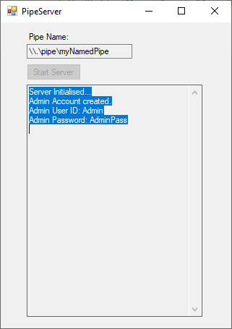

### Client Connection Stable

The client connection is stable and provides the appropriate connection message

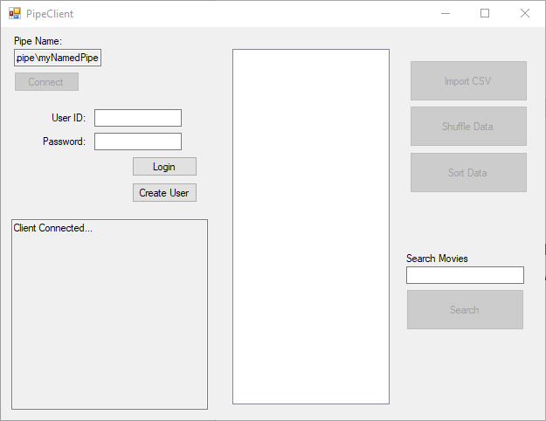

# User Creation

The client successfully creates sends new user information and receives a returned message from the server identifying that user account creation was successful.

### Client

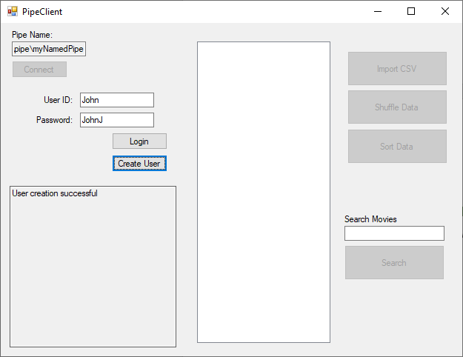

### Server

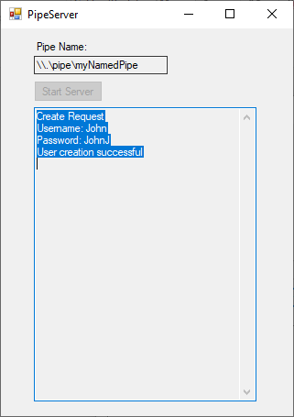

# User Login

The client logs in with the newly created user credentials successfully, and the full feature suite of the client program is unlocked

### Client

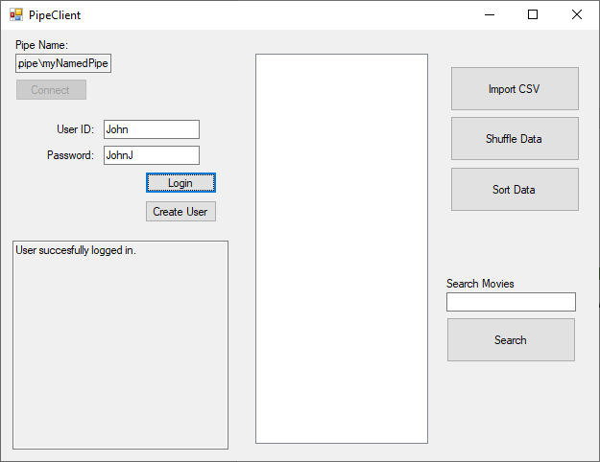

### Server

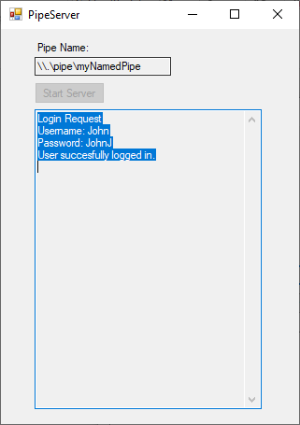

# CSV Import

The client successfully imports data from the .csv document, and the data is uploaded into the output list box.

### Client

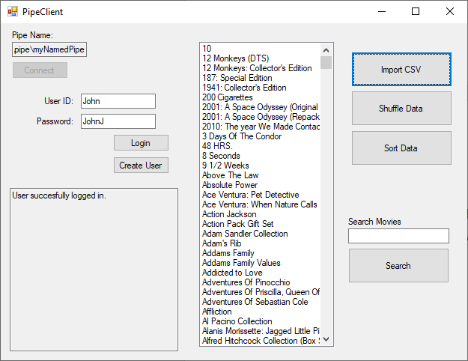

# Data Shuffle

The client successfully shuffles the data and repopulates the Output list box with the shuffled data.

### Client

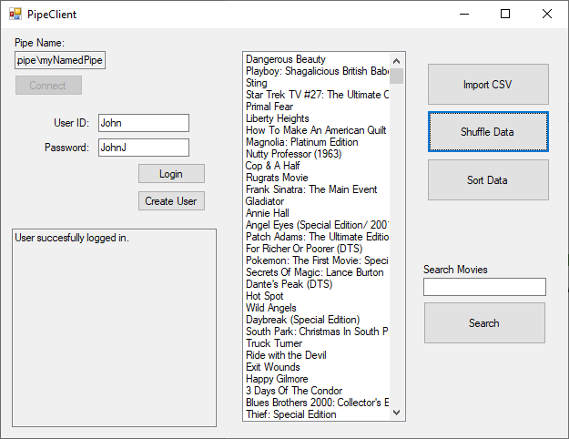

# Data Sort

The client successfully sorts the shuffled data and repopulates the list box with the sorted data.

### Client

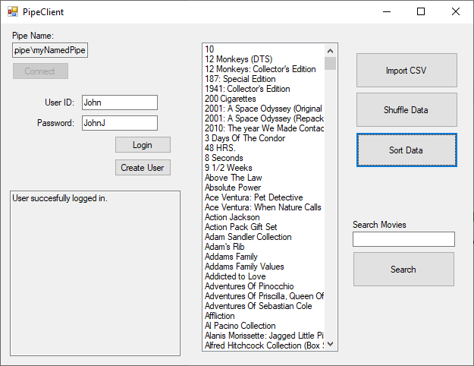

# Search Function

The search function successfully finds the item matching the search term when the input is correct

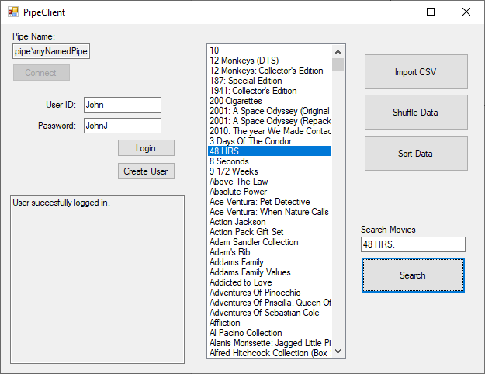

The search term also displays an error message if the search term was incorrect or incomplete

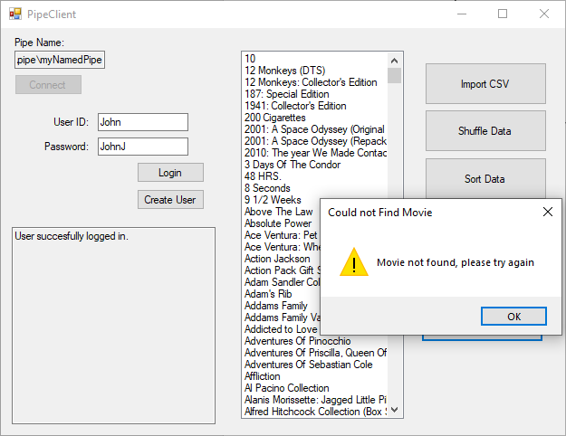

The search function also correctly finds the item when the data has been shuffled

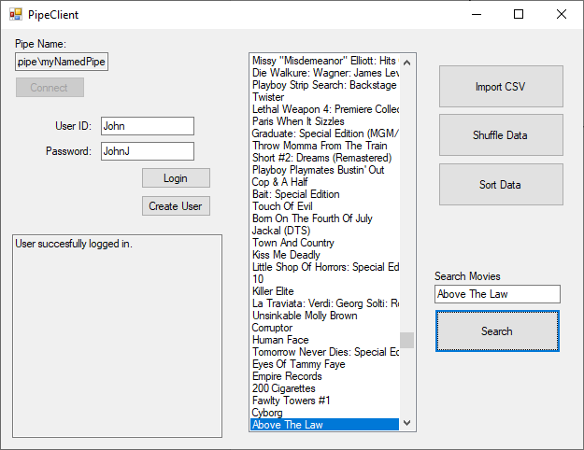

# Close Connection Hotkey

The Client application successfully closes the connection when the CTRL + X hotkey is pressed

